**NAND GATE**

The NAND gate operates as an AND gate followed by a NOT gate. It acts in the manner of the logical operation "and" followed by negation. The output is "false" if both inputs are "true." Otherwise, the output is "true."

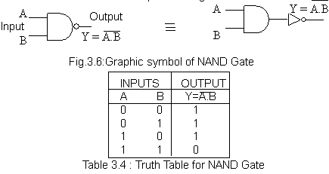

It is a simple matter to make a NAND gate out of transistors and a resistor:

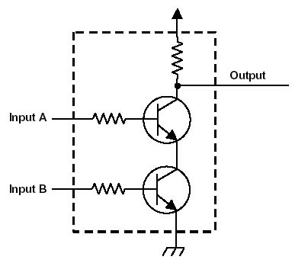

The resistors on the inputs limit the base-emitter current to just enough to turn the transistors on. It is important to understand that the inputs are not connected to the output, they only determine whether the output is connected to +5V or 0 V. You can see that this circuit performs the NAND operation. If both transistors are on (inputs +5V or 1) the output will be connected to ground (be at 0V or 0). If either transistor is off, the output is connected through the resistor to +5V. Here is the circuit behavior presented as a truth table:

